Instruction Manual

Q-CONNECT A4 Guillotine Trimmer
KF11241

Paper Stop
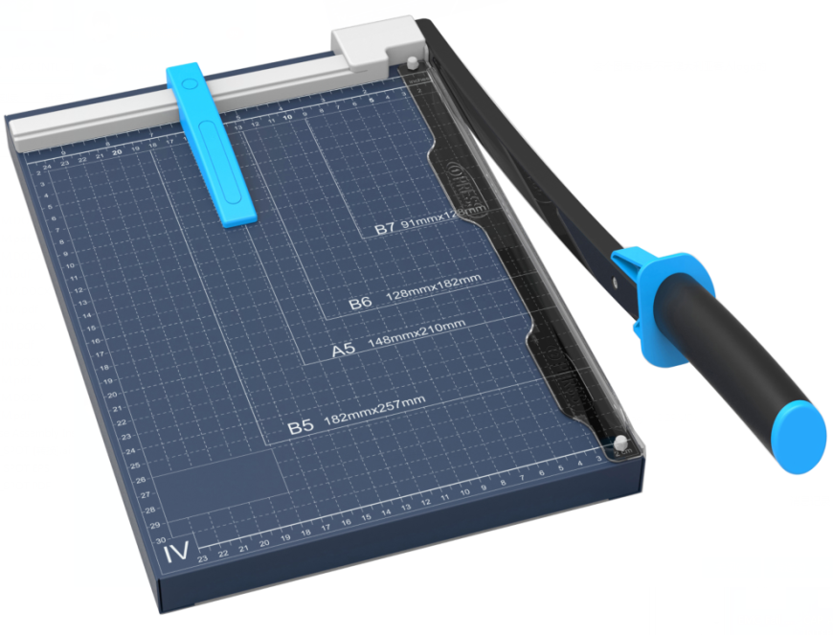

Transparent Blade-guard
Handle

Read all instructions before use. Keep for future reference.

Guillotine Trimmer

Model | KF11241
Max. paper size | A4
Cutting length | 320mm
Max cutting capacity  (80gsm paper) | 10 sheets
Cutting table | 250x320mm
Dimensions | 350x300x60mm
Weight | 2.20kgs

INSTRUCTION
Before starting to use this paper guillotine, install the handle by rotating as shown in image below.

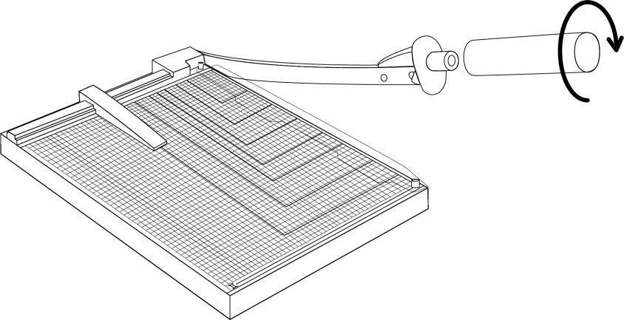

Place the guillotine on a stable flat surface. Lift the blade up to its maximum position. Place the paper on the guillotine underneath the transparent blade-guard, and then lower the blade.

Note: Place the paper into the position as shown in images below to start cutting paper.
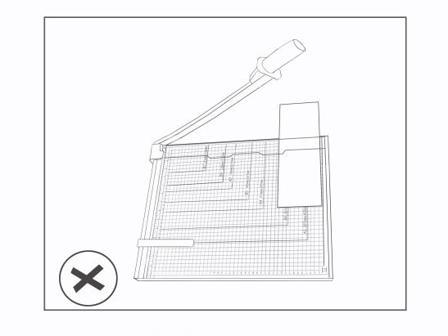
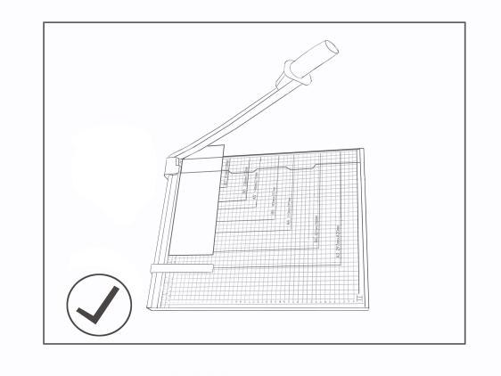

MAINTENANCE
- Clean guillotine with a dry cloth. Never use solvents or water. To prolong the life of the blade, it is recommended to regularly wipe it down with silicone fluid, liquid Vaseline or other rust-preventative oil.

- Should the blade loosen, follow the 2 below steps to tighten the blade:
[A] Use a screwdriver to dismantle the grey part as shown in the image below.
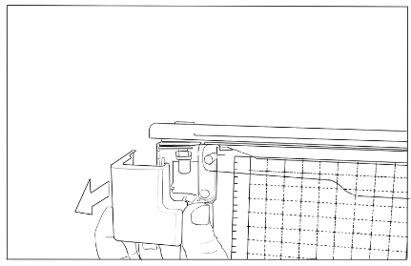

[B] Use a hex screwdriver to tighten the screw bolt with one hand, while using a wrench to hold the nut in place with the other hand. See image below.
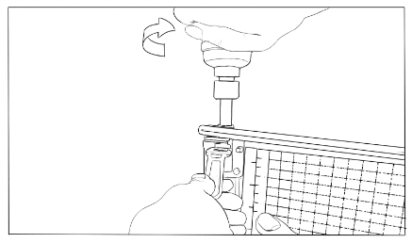

NOTE

- When not in use, the guillotine blade should be placed down (in horizontal position).
- Using more than the recommended amount of paper could cause permanent damage to the blade.
- This product is intended for cutting of paper. Do not use the product for any other purpose.
- This product is not intended for use by children. Keep product out of reach of children.

To avoid damage to the product:
- Remove paper clips and staples from paper before cutting paper.
- Do not expose product to humidity, water or other liquids.

During use, the protective black coating of the blade may wear off over time.

To avoid possible severe personal injury:
- Always operate the product on a flat, level and steady surface to avoid overturning.
- Always operate the guillotine with the transparent blade-guard in place.
- Never carry the guillotine by the blade.
- Never carry the guillotine by the cutting handle.

